

Swinburne University of Technology
Lab01
REPORT
Applied Machine Learning - COS30082
Student Name: Truong Ngoc Gia Hieu
Student ID (VietNam): SWS01217
StudentID (Australia): 105565520
TABLE OF CONTENT

Local Installation
According to the guidance of the Lab01 (Getting Started) of Week01, I download the Anaconda Distribution version from the website https://www.anaconda.com/ . After completing the installation on my local computer, the Anaconda Navigator Dashboard was displayed.

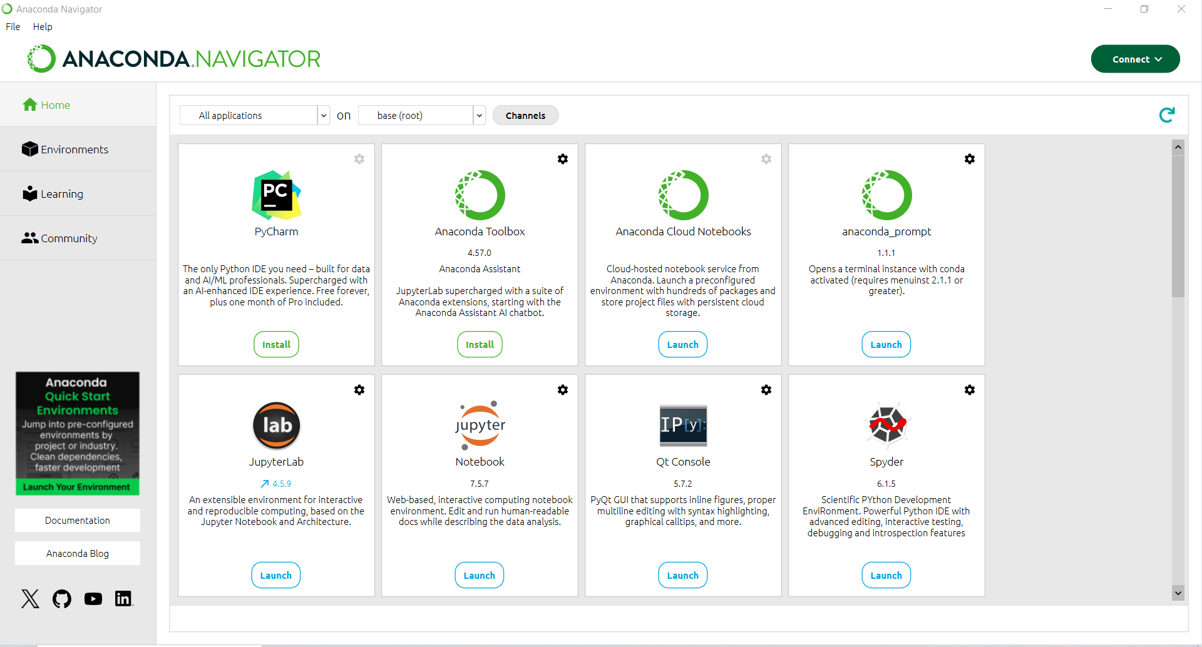
Figure 1: Anaconda Dashboard

Regarding of Jupyter Notebook, choosing Launch button on Jupyter Notebook.

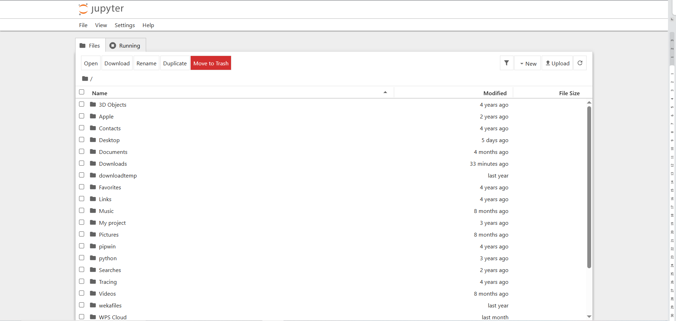
Figure 2: Jupyter Notebook Dashboard

Colab Running
Regarding of using resources, my Google Colab utilizes the CPU:
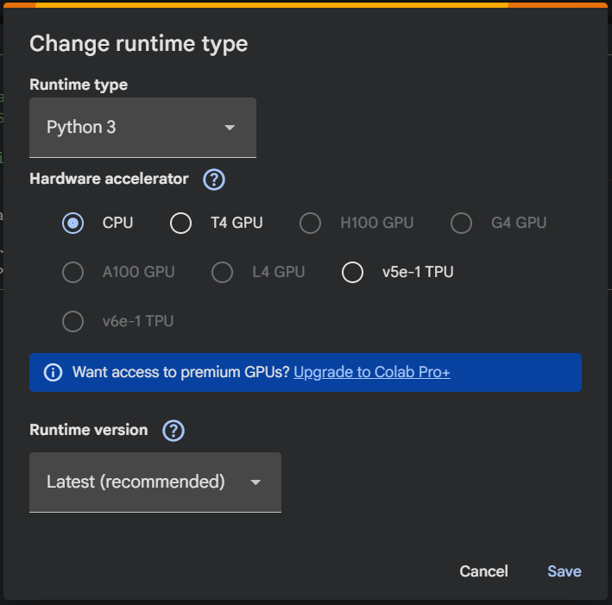

Figure 4: Configuring hardware accelerator in Google Colab

In the guidance document, the instructions recommend each student should generate a .csv file that contains following data:

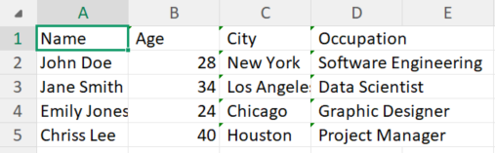
Figure 3: Data preview from file Citizen.csv

Next, I created file named Lab01.ipynb which I can download whole file .ipynb after finishing all tasks in the first laboratory.
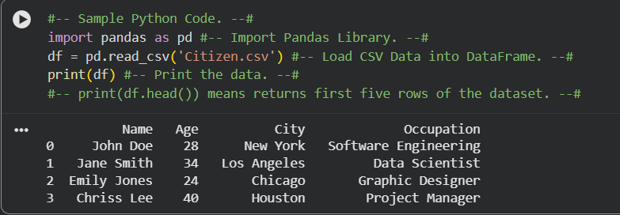
Figure 5: Python code and data return from Citizen.csv

Firstly, based on my search, the Pandas library primarily used for data manipulation, cleaning, exploration, and analysis. Therefore:
- The first line import pandas as pd is for importing Pandas library.
- The second line is for assigning data has been read from file Citizen.csv to variable named df.
- Last line used for prinitng all data (NOTE: .head() in Pythong is print automatically for first 5 rows from the dataset so if I want to print more, I have to put number of rows that I want to see such as df.head(10))

